***From the Desk of Michael L. Parson and Teresa Parson***



Greetings,

As Governor and First Lady of Missouri, we have the privilege of serving more than six-million Missourians, including Missouri children. Our children are the future, and it is for their future that we ask that you join us on November 5 and vote NO on Amendment 3.

Pro-abortion groups have spent nearly $20 million to promote this extreme pro-abortion amendment and change our Missouri Constitution. Nearly 75 percent of financial support can be traced to out-of-state donors, including funds linked to George Sorors, Michael Bloomberg, and Planned Parenthood. The language of this amendment was written by lawyers and pro-abortion activist groups, and limits Missourians’ and their elected representatives’ ability to deliberate on health and safety standards for women and children.

It also opens the door to allow children to get sex change operations without parents’ knowledge in our state. Missourians have a strong history of protecting our children and in 2023, when left up to Missourians to write and debate these issues, we prohibited health care providers from performing gender transition surgeries or prescribing hormones or drugs for the purposes of gender transition to Missouri children under the age of 18. These decisions have permanent consequences for life and should not be made by impressionable children who may be in crisis.

In 2019, we passed the “Missouri Stands for the Unborn Act,” which prohibited an abortion in a non-medical emergency past 8 weeks of gestational age. In 2022, we activated the "Right to Life of the Unborn Child Act," which ended elective abortions in Missouri while providing exceptions for the health and safety of mothers. In 2023, we expanded health care coverage and developed a maternal mortality prevention plan to support Missouri’s expecting and postpartum mothers. Missouri remains one of the most pro-life states in the nation, and we will continue to fight for the life of every unborn child.

We believe our children have God-given value and worth. As Governor and First Lady, we have remained dedicated to our children, grandchildren, and great-grandchildren, and we have worked hard to protect each Missouri child and give them their shot at the American Dream.

We ask that you join us in lifting up our state in prayer this election cycle and voting NO on Amendment 3.

Sincerely,

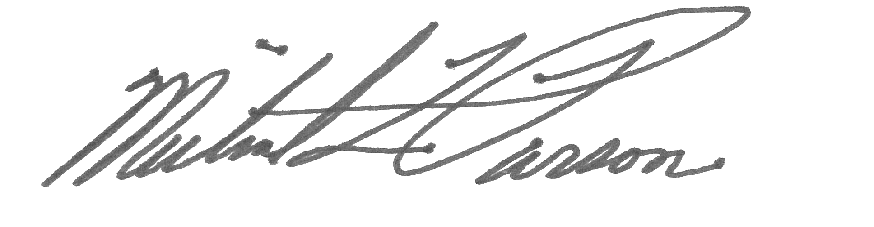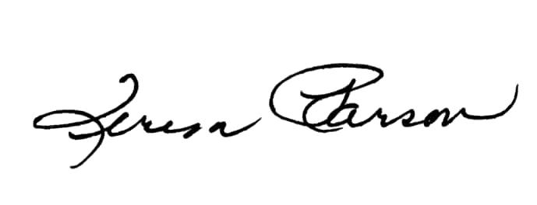

Michael L. Parson and Teresa Parson