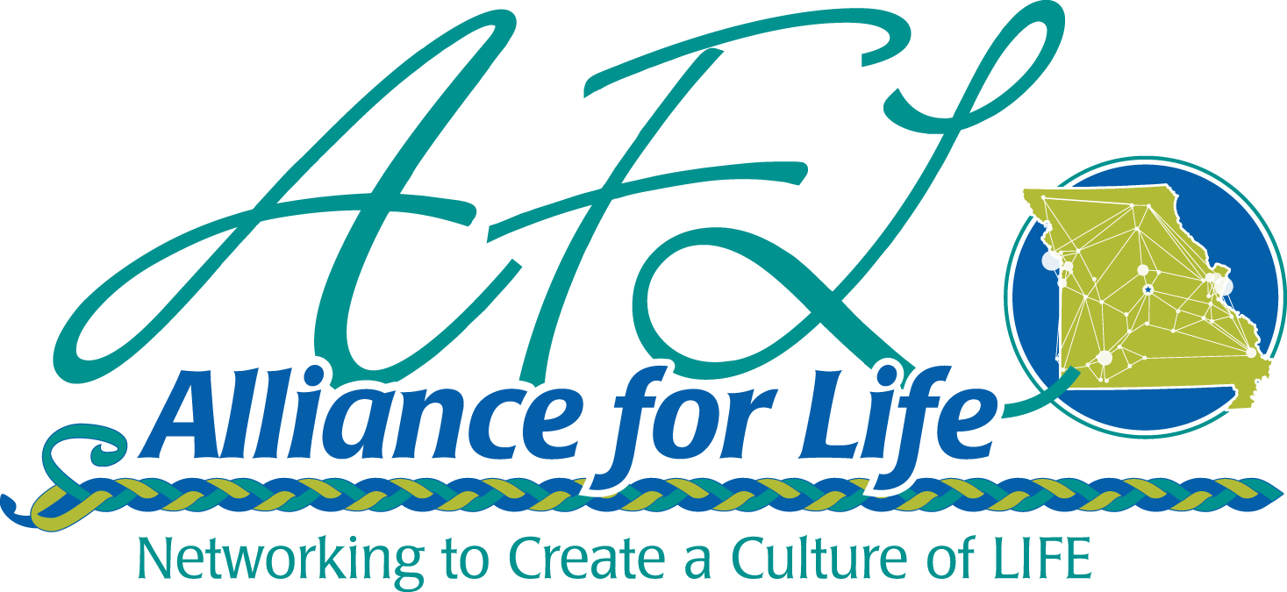

2022 Enrichment Day
Partnership Opportunity

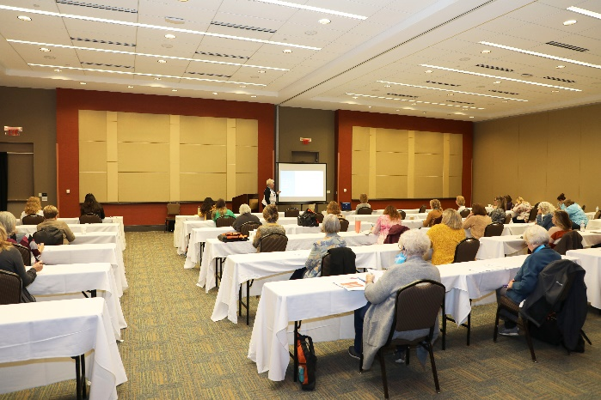
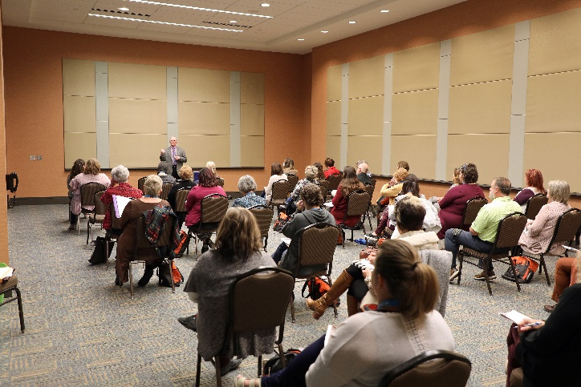

Alliance for Life Missouri
487 SW Ward Rd
Lee’s Summit, MO 64081
allianceforlifemissouri.com

Enrichment Day Package — Only $250*

Limited Time Offer
Expires April 1st.

We are pleased to offer a one-day exposure package! Enrichment Day is an annual training event AFL provides to our affiliates and will be held on April 14th. It is similar to our annual conference in the fall but lasts only one day. Attendees would include board members, Executive Directors, staff and volunteers from pregnancy care centers, maternity homes, adoption agencies and post-abortive recovery providers. Don’t miss out on a great opportunity to be featured prominently in front of life organizations this spring!

*$175 for our 2022 Champion or Game Changer business partners.
What you get:
- Live 2-minute Zoom call (or a video, if you prefer) during a General Session
- Feature write-up on Facebook including link to your website and Facebook page
- Prominent logo appearance day of event
- Logo appearance on all event communication promotions (print and digital) prior to event, provided business submission and payment is received by April 1st.

- One piece of literature or promotional material distributed to each attendee

To Become a Sponsor:

Visit our website: https://allianceforlifemissouri.com/events/business-partnerships/
and click Enrichment Day Partner
or call our office at 816-806-4168

